Skin Cancer Detection using CNN

Proposed Architecture

## Image acquisition

In Image Processing, it is defined as the action of retrieving an image from some source, usually a hardware-based source for processing. It is the first step in the workflow sequence because, without an image, no processing is possible. The image that is acquired is completely unprocessed.

For this project, the original dataset has been obtained from the Kaggle and the dataset has been uploaded into the Google Drive as a zip file. With the help of a Python Library, the Google Drive can be authorised using which we can access the dataset by just importing the dataset into the model and then unzipping it.

## Image Pre-processing:

**Image processing** is divided into analogue image processing and digital image processing. **Digital image processing** is the use of computer algorithms to perform image processing on digital images. As a subfield of digital signal processing, **digital image processing** has many advantages over **analogue image processing**. It allows a much wider range of algorithms to be applied to the input data — the aim of digital image processing is to improve the image data (features) by suppressing unwanted distortions and/or enhancement of some important image features so that our **AI-Computer Vision**models can benefit from this improved data to work on. An image is nothing more than a two-dimensional array of numbers (or pixels) ranging between 0 and 255. It is defined by the mathematical function f(x,y) where x and y are the two co-ordinates horizontally and vertically. The value of f(x,y) at any point is giving the pixel value at that point of an image. The dataset is then divided into the train set and test set of 80% and 20% images respectively.

## Feature Extraction

Feature extraction is a process of dimensionality reduction by which an initial set of raw data is reduced to more manageable groups for processing. A characteristic of these large data sets is a large number of variables that require a lot of computing resources to process. Feature extraction is the name for methods that select and /or combine variables into features, effectively reducing the amount of data that must be processed, while still accurately and completely describing the original data set.

The process of feature extraction is useful when you need to reduce the number of resources needed for processing without losing important or relevant information. Feature extraction can also reduce the amount of redundant data for a given analysis. Also, the reduction of the data and the machine’s efforts in building variable combinations (features) facilitate the speed of learning and generalization steps in the [machine learning](https://deepai.org/machine-learning-glossary-and-terms/machine-learning) process. The dataset comprising of RGB images of skin samples has been taken. The images are 1024x1024 which are resized to 224x224 pixels.

## Classification:

We will be classifying the images as into two categories:

1. Malignant (Cancerous)
2. Benign (Non-cancerous)

## Network Architecture

### Pre-processing

#### Data Preprocessing

##### Read Image

In this step, we store the path to our image dataset into a variable then we created a function to load folders containing images into arrays. But first, we need to import the libraries that we are going to use

##### Resize Image

In this step-in order to visualize the change, we are going to create two functions to display the images the first being a one to display one image and the second for two images. We need to resize the images because some images captured by a camera and fed to our AI algorithm vary in size, therefore, we should establish a base size for all images fed into our AI algorithms.

##### Splitting the Data

The dataset will be split as:

* Training Data: 70%
* Validation Data: 15%
* Testing Data: 15%

#### Image Preprocessing

##### Convert into Array and then into Tensors

The images are converted into arrays because the images will be processed as arrays and the images will be further converted into tensors because the tensors have the following adantages:

* It avoids multi-linear data structure loss
* Computations can be enhanced for classical data processing
* Multi-dimensional data image can be more efficient and effective

After converting, we will also obtain the respective labels for all the images

#### Building

##### Neural Network

We have built a Sequential Neural Network for which we have resized the images to the 224x224 with three channels. The layers of the network are 2D Convolutional Layers with 128 filters and kernel size as (3,3). The Activation functions used are ReLU. The model consists of an Ensemble Model which consists of the following Pre-trained Models:

* MobileNet
* InceptionV1
* Xception
* Convolutional neural Network

# Architecture and Process Flow Model for the Proposed Model

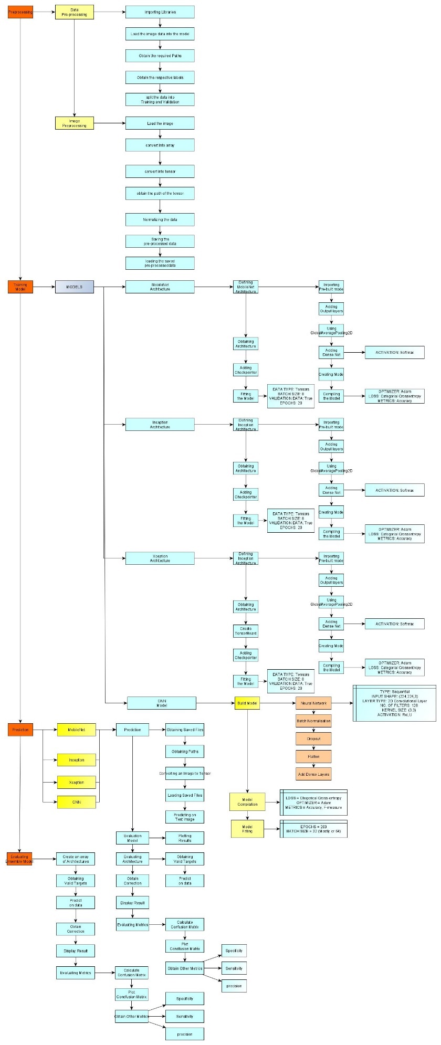

Figure 3 Proposed Architecture

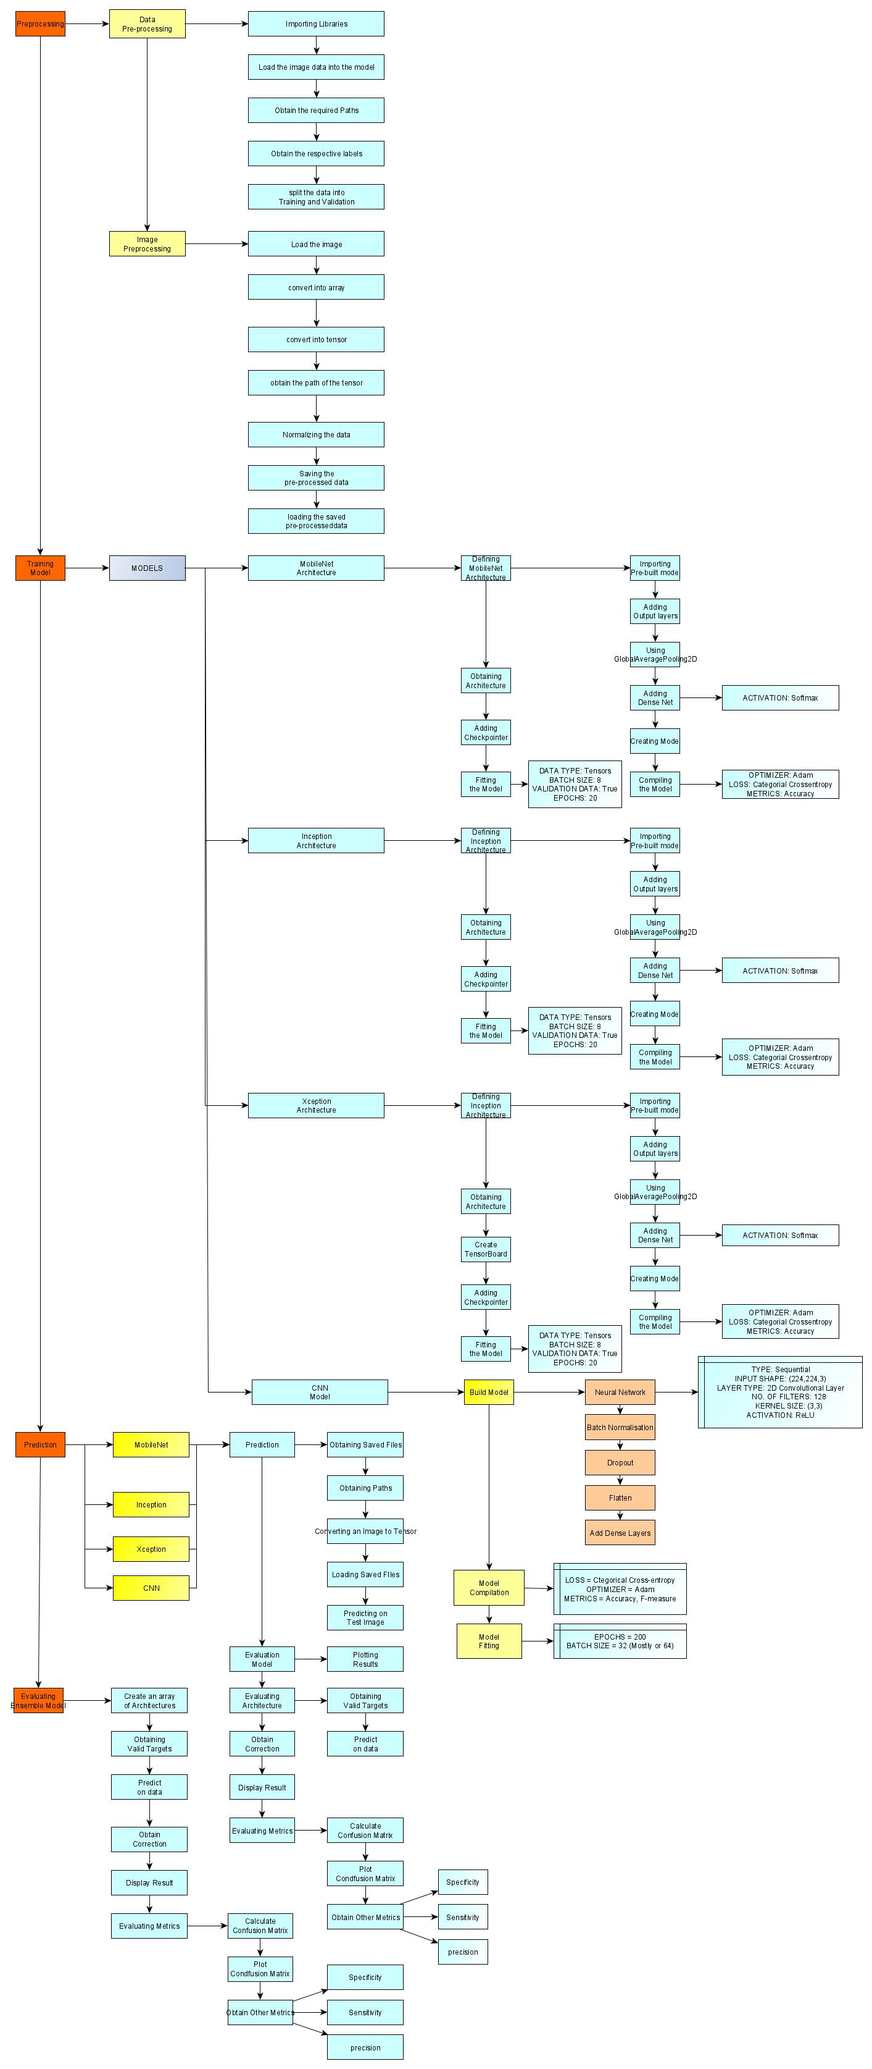

Figure 4: Proposed Architecture (Lower-half)

# Methodology and System Design

## Image Processing

* Image processing can be defined as the technical analysis of an image by using complex algorithms.
* The purpose of early image processing was to improve the quality of the image. Its use has been increasing exponentially in the last decades.
* Its applications range from medicine to entertainment, passing by geological processing and remote sensing.

## Convolutional Neural Network

* A Convolutional Neural Network (CNN) is comprised of one or more convolutional layers (often with a subsampling step) and then followed by one or more fully connected layers as in a standard multilayer neural network.
* The architecture of a CNN is designed to take advantage of the 2D structure of an input image. This is achieved with local connections and tied weights followed by some form of pooling which results in translation invariant features.
* Another benefit of CNNs is that they are easier to train and have fewer parameters than fully connected networks with the same number of hidden units.

## Proposed Simple Process Flow Diagram

The model has been described using the simple image given below:

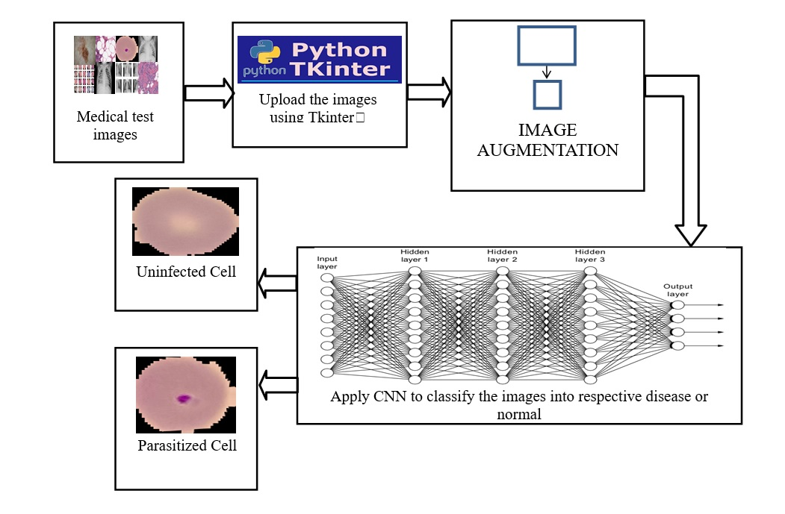

This is the way the project is going to flow. First a medical test image will be taken which will be uploaded to GUI-based software (made with the help of Tkinter) and then the image will be processed using the model which has been saved as a file and has been integrated with the software for faster processing. The model will generate an output which will be returned to the software and the final output will be displayed to the user on the screen, based on which the medical diagnosis for the patient can be started at an early stage and help save many lives due to the delay in the provision of the medication.